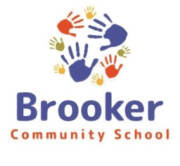
A Special Call Board Workshop was held on September 14 to discuss policies.
The meeting opened by Chair Suzanne McRee at 6:02. She set the purpose of the workshop.
Grant Question and answer session
Richard Trainor, called in to the meeting to answer any questions regarding purchase protocol within the grant.
Grant wish list / items discussed:
Bus – No issue with buying a used bus. Option to trade the bus for a newer model in the 2nd
year. New and used bus will be put in the budget. New - Loaded $151.360 12 – 13 months ordered; Used - $45,000 2014 w/1000,000 miles. Purchases will need at least 3 quotes in order to justify the price. A new contract w/ Bradford County for maintenance fees, inspections, and gas at the bulk rate.
Reimbursements – We are able to go back 3 months from the day the grant letter is signed.
October would be the month and July will be the deadline of reimbursements from the grant.
Budget Narrative – Function and Object Codes. Notification provided for items not approved.
Grant purchases – Keep on file. No expiration of any items bought with grant money.

Dr. Moss and Mr. Starling will update narrative. Law equipment to be added to the narrative.

Policy Manual will cover all 12 sections addressed in the charter school manual. As a charter school this is a requirement and polices may be amended as needed. Board members present designated polices to the meeting. These policies will be voted in for approval at the regular board meeting, September 19.

Friday agenda for next meeting will not include a new budget financial statement.

Workshop meeting was adjourned at 7:41 pm.

